Solving the problem of ‘Global Warming’

***“****Who* is emitting the most greenhouse gasses?***”***

* The US is responsible for the highest number of emissions, and Americans have the highest carbon footprint per capita
* 100 companies (most of them oil and coal producers) are responsible for *71%* of the world’s greenhouse gas emissions.

***What is Global Warming?***  
  
A gradual increase in the overall temperature of the earth's atmosphere generally attributed to the greenhouse effect caused by increased levels of carbon dioxide, CFCs, and other pollutants.

***Causes:***  
"Greenhouse gases like methane, nitrous oxide and most prominently carbon dioxide along with other air pollutants is the main cause for global warming."

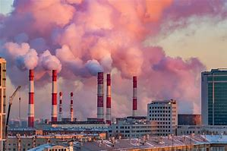

*Is it a human-made cause?*

* **Higher Levels of Deforestation**
* **Transportation and Use of Vehicles**
* **Emissions of Chlorofluorocarbons**
* **Emissions from Industries and Power Plants**
* **Agriculture and Land Surface Changes**
* **Combustion of Fossil Fuels, Overpopulation**

*Natural Causes of Global Warming*

1. **Volcanic Eruptions:** They constitute one of the significant natural causes affecting global warming because of the increased release of gases and smoke from the eruptions.
2. **Natural Forest Fires:** When significant scale vegetation burns, leading to forest blaze, there is a release of stored carbon and a rise in greenhouse gas emissions. These emissions further trap solar energy leading to Global warming.
3. **Melting Permafrost and Glaciers:** Towards the north and south poles of the planet, considerably large amounts of carbon are frozen in the form of permafrost. Disturbances such as solar activities, forest fires, volcanic eruptions can lead to the sudden release of GHGs and carbon sequestration into the atmosphere, giving way to ecological imbalances.
4. **Solar Activities:** Changes in solar irradiance in wavelengths and other [variations](https://www.vedantu.com/biology/variations) such as solar flares or sunspots, if larger enough, could have an unprecedented impact over global warming and atmospheric temperatures.

***Some Facts & Figures:***

## **What are the Top 10 Crucial Global Warming Statistics to Be Aware Of**

* 60% of Americans view [global warming as a significant threat](https://petpedia.co/global-warming-statistics/#global%20warming%20as%20a%20significant%20threat).
* There is a [99.9999% chance humans are responsible](https://petpedia.co/global-warming-statistics/#99.9999%%20chance%20humans%20are%20responsible) for global warming.
* It would take [$140 billion a year](https://petpedia.co/global-warming-statistics/#$140%20billion%20a%20year) to adapt to climate change.
* [CO2 in the atmosphere](https://petpedia.co/global-warming-statistics/#CO2%20in%20the%20atmosphere) hasn’t been this high in 3 million years.
* During the Covid-19 pandemic, [CO2 emissions dropped by 7%](https://petpedia.co/global-warming-statistics/#CO2%20emissions%20dropped%20by%207%).
* The planet’s surface temperature has [increased by around 1.62°F](https://petpedia.co/global-warming-statistics/#increased%20by%20around%201.62%C2%B0F).
* Humans influenced [68% of all extreme weather conditions](https://petpedia.co/global-warming-statistics/#68%%20of%20all%20extreme%20weather%20conditions) in the last 20 years.
* Heatwaves are [30 times more likely to occur](https://petpedia.co/global-warming-statistics/#30%20times%20more%20likely%20to%20occur) as a result of climate change.
* Sea levels are [rising three millimeters a year](https://petpedia.co/global-warming-statistics/#rising%20three%20millimeters%20a%20year), the fastest rate in 3,000 years.
* People have cleared [30% of all forest cover](https://petpedia.co/global-warming-statistics/#30%%20of%20all%20forest%20cover) on the planet.

Hopefully, these stats will shock you into action. We all need to do our part to help save our planet from total destruction.

***Effects:***

The major impacts of global warming include societal, economic, and health impacts. It can cause a lot of harm if it continues the same way as it is happening now. Here are its certain impacts:

1. **Rise in Temperature Leading to Ice Melt:** Melting glaciers and snow melts will cause severe water shortages and droughts with higher frequencies giving way to heatwaves and extreme weather conditions in the mid-latitudes. Thinning ice of the northern seas will make the atmospheric conditions vulnerable to control.
2. **Ecological Risks:** Global warming has contributed to the extension of drier climatic zones such as deserts in the subtropics. Mostly ecosystems and animal life will be affected by higher carbon dioxide levels and global temperatures leading to climate change, which will result in the extinction of many species and reduced ecological diversity.
3. **The Threat to Marine Life:** Global warming can lead to the destruction of marine and coral life underwater. Higher content of carbon dioxide in the water inflicts damage to valuable natural resources.
4. **Loss of Settlements:** Global warming can also lead to Inundation from sea level rise, which can further threaten infrastructure and establishments of human settlements. This severely leads to a decrease in the human [population](https://www.vedantu.com/biology/population). Droughts, temperature rise, loss of glacial rivers puts the state of agriculture on ain the rampage.
5. **Health Factors:** There are various indirect effects such as malnutrition inflicted by crop failures. Scanty rainfall leading to desertification can also cause several diseases due to global warming.

Flooding in low-altitude regions: Rise in sea level and high flooding tendencies can damage human habitation and cause mass destruction.

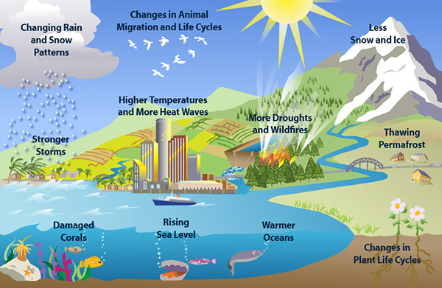

***The Solution –***  
Some of the most impactful solutions for global warming (in no particular order) that *you* can do, today – and can pick and choose as you see fit:

**1. Plant trees**

**What to do:**

* Plant trees in tropical rainforests in Brazil, Indonesia, India, Colombia, and Madagascar. (If you plant trees through [Treedom](https://www.treedom.net/en/plant-a-tree), you can choose the type of tree you plant based on how much carbon it removes from the atmosphere.)
* Protect what remains of our existing tropical forests through nonprofits such as Cool Earth

**Why it’s impactful:**

Reforestation is **the most cost-effective way** to prevent global warming, according to research presented at the American Association for the Advancement of Science conference. Why?

Trees absorb carbon dioxide (reminder: which makes up 82% of greenhouse gases in our atmosphere), so planting more trees can help reduce the amount of carbon in our atmosphere. In fact, we could remove roughly **two-thirds** of human-made carbon just by letting all forests regrow, according to a study published in the journal of *Science*. Yep, two-thirds.

Plus, as Jaron Pazi from Treedom told us,

*“Trees do more than absorb carbon. When planted in sustainable agroforestry systems, they result in enhanced biodiversity, water retention, soil health, food security and economic development for local communities.”*

But not all forests are created equal – some remove carbon from our atmosphere more effectively than others. According to a paper published in *Science Advances*, tropical forests in countries like Brazil, Indonesia, and India will most efficiently pull carbon out of the atmosphere, since they’re home to a huge amount of biodiversity and play a major role in the planet’s air and water cycle.

**2. Create more sustainable transportation habits**

You knew this one was coming…

**What to do:**

Do at least one of these things:

* Instead of ordering a private ride, do a rideshare
* Avoid rapid acceleration and braking, and turn on cruise control on longer trips
* Walk and bike to your destination whenever possible
* When buying a new car, choose a climate-friendly option (here’s a [good tool](https://climatefriendlycars.climatecentral.org/) to find a climate-friendly car)

**Why it’s impactful:**

As aforementioned, cars are one of the biggest contributors to climate change: 82% of emissions from transportation come from cars. And while cutting automotive transportation out of your life would make the most impact, this isn’t possible for most people. So instead, tweak a few habits that will have a bigger collective impact.

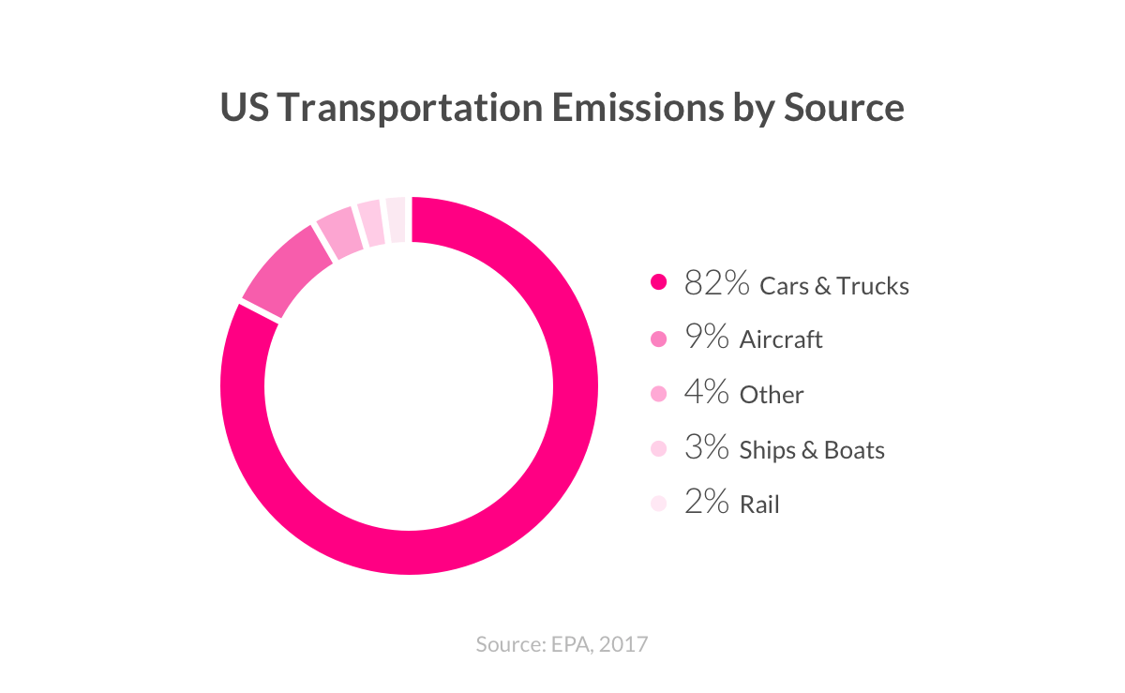

For example, if you refrain from harsh braking and rapid acceleration, you can cut your fuel consumption by as much as 40%, according to the US Department of Energy. If you also keep your tires inflated and car maintained, you’ll cut your fuel consumption by nearly *half*when driving.

**3. Lower your heating bill**

**What to do:**

In the winter, take steps to lower your heating bill:

* Set your thermostat at 68 degrees F, and lower your home’s temperature 7-10 degrees for 8 hours a day. (But don’t turn down the heat more than 10 degrees if it’s only for a few hours- it’ll take too much energy to heat back up.)
* Shore up your windows, seal up the doors, and plug up dafty holes (here’s a comprehensive guide that [shows you how](https://www.lemonade.com/renters/explained/tips-winterize-apartment/)).

**Why it’s impactful:**

Electricity is one of the biggest causes of greenhouse gas emissions, and heating systems are the single biggest energy expense in the home. So lowering your heating bills is the most impactful way to reduce your electricity consumption (and isn’t so bad for your wallet, either).

In addition to monitoring your thermostat, improving insulation and airtightness through your walls, roof, and windows is a great way to avoid heat from escaping your home, since the biggest sources of heat loss are your walls (35%), roof (20%), and windows (15%).

**4. Divest from coal, and encourage others to do the same**

**What to do:**

* Divest your 401k from fossil fuels (you can analyze your stocks on [fossilfreefunds.org](http://fossilfreefunds.org/), which shows what % of your funds are invested in fossil fuel companies)
* Make sure your bank, insurance company, and university (some of the world’s biggest investors in coal) have agreed to divest. If they haven’t, call on them to do so.

**Why it’s impactful:**

Coal-burning power plants are by far the *biggest* emitters of carbon dioxide in our atmosphere, according to the Natural Resources Defense Council. Aka, coal is a big deal.

20% of industrial coal emissions are funded by public investors. So when people or companies *stop* investing, it’s more difficult for coal producers to finance more coal production.

For example, “the more insurance companies that join the divestment effort, the more difficult it will become for companies to derive significant revenue from burning coal,” Bloomberg Journalist Bryony Collins wrote. That’s why [Lemonade became the first US insurance company to not invest in coal](https://www.lemonade.com/blog/divest_coal/).

Case in point: When the world’s biggest coal company (Peabody) announced bankruptcy, it said the divestment movement had made it difficult to raise capital.

**5. Eat less beef**

**What to do:**

Create a rule for yourself that limits your beef consumption, such as:

* Don’t cook beef at home – only eat it out
* Only eat beef on the weekends
* If there’s an option to choose between beef or another protein when ordering a dish, go with the alternative protein

**Why it’s impactful:**

Emissions from animal agriculture account for around 15% of all human emissions, and beef is responsible for 41% of that, according to the UN Food and Agriculture Organization.

If cattle were their own nation, they would be the world’s third-largest emitter of greenhouse gases. Let that sink in.

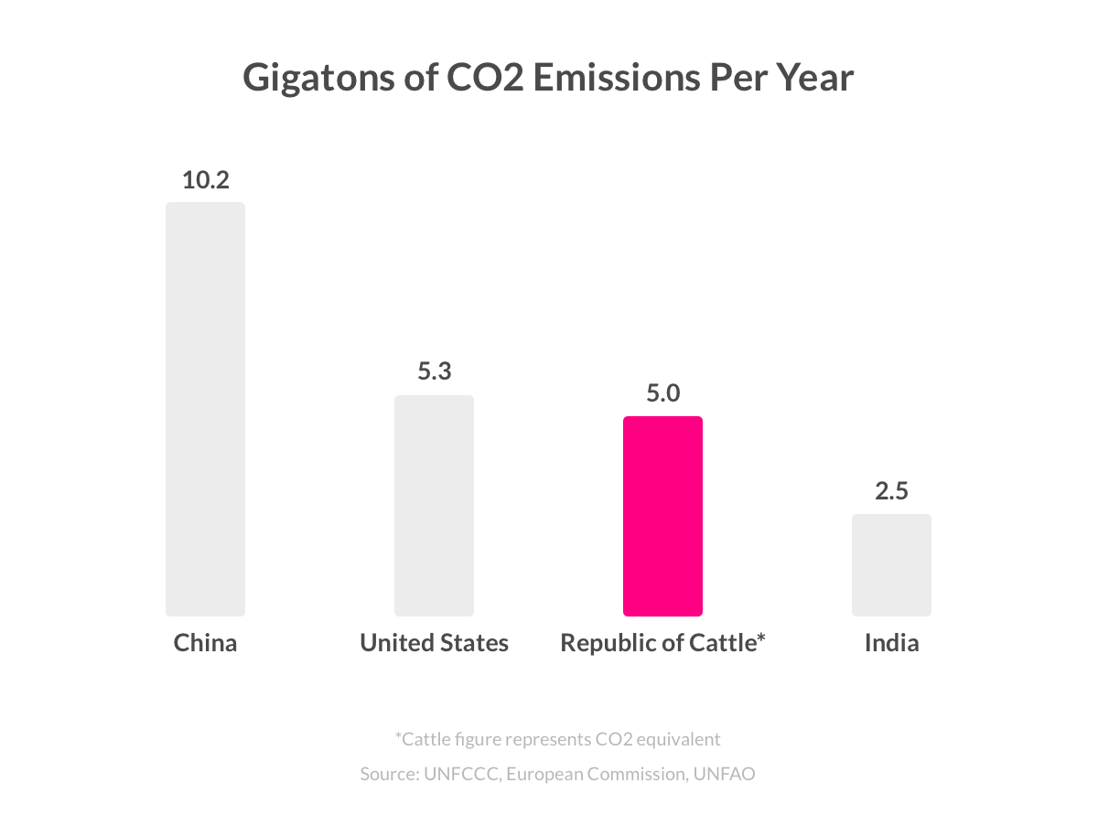

Why?

Beef production requires 28x more land, 6x more fertilizer, and 11x more water than these other proteins than the calorie-equivalent of pork or chicken, according to a paper published in *Proceedings of the National Academy of Sciences*.

And if you factor in deforestation to make way for livestock, along with methane emissions from cows and fertilizer use, beef production creates as much greenhouse gas emissions as all the world’s cars, trucks, and airplanes combined, according to *The Guardian*.

**6. Educate girls**

**What to do:**

Give to a charity that makes school more affordable and accessible for girls in low- and lower-middle-income countries, such as the [Malala Fund](https://www.lemonade.com/l/malalafund).

**Why it’s impactful:**

In the most comprehensive report on effective climate solutions, Project Drawdown named educating girls as the #6 most impactful solution (for reference, composting is #60, and rooftop solar is #10).

That’s because women with more years of education have fewer children, and therefore a lower carbon footprint. Not only that, but “women have a disproportionate share of decision making around water, cooking, food waste, fuel choices, and how homes are heated, built, and used,” said scientist Jonathan Foley. “It’s one of the most powerful climate solutions of all.”

“Educating girls is one of the most cost-effective, high-impact ways for every nation to fight rising temperatures,” Shabana Basij-Rasikh shared on TED. “It’s not a topic most Westerners think about, since girls’ education is a given. ”

**7. Advocate for a healthy planet**

**What to do:**

Support climate legislation by doing one or more of these things:

* Send a letter to party leaders and candidates telling them your vote depends on their stance on global warming
* Volunteer for a candidate that supports efforts to stop global warming
* Talk to friends and family about the importance of voting for climate action
* Write a letter to your elected leaders to support and implement a set of climate solutions

**Why it’s impactful:**

Reminder: 100 companies produce 71% of emissions worldwide. What will compel big companies to act sustainably consistently, on a large scale? Lawmakers.

They can:

* Place limits on the amount of carbon companies are allowed to emit
* Provide resources to prevent emissions leaks from equipment
* Subsidize efficient industrial technology to make it more affordable

They can also help *individuals* act more sustainably. Copenhagen’s government is working to make it the world’s first carbon-neutral city by 2025, by installing bike lanes across the city, restricting polluting cars, and building new wind turbines.

And how can we enact political change? It all starts with you.

**8. Convince your friends to behave sustainably**

**What to do:**

Choose an impactful, sustainable behavior from this list, and try to convince your friends to do it too. Using the example of ridesharing, you can say things like:

1. “I talked to Jordan, Leah, Hannah, and Danny, and they’re all ridesharing. Are you?”

2. “When’s the next time you’re going to rideshare, and what app are you going to use?”

3. “You’re a ride sharer, aren’t you?”

4. “I’ll text you next week to see how the ride sharing has been going!”

**Why it’s impactful:**

While *you’re*on your way to becoming a climate warrior, your friends and family members might not. Because of a little thing called the drop-in-the-bucket effect (read: “my actions won’t actually make a difference”), 80% of Americans don’t consistently make an effort to live a sustainable life, according to Pew.

And since Americans have the largest footprint worldwide, convincing your friends and family to reduce their emissions can transcend our own impact, and inspire others to help save our planet as well.

Giving your friends these nudges is scientifically proven to help sway them to act sustainably. For example, one of the biggest findings in [behavioral science](https://www.lemonade.com/blog/social-science-coronavirus/) is that humans are motivated to do what other people around them are doing. If you tell your friend that your other friends are using sustainable light bulbs, they’ll be more compelled to do so, too.